Things can be stored in local storage and session storage in browser

**Local storage**: can be stored update 5MB data and it persists until cleared manually/programmatically

**Session storage**: available only for current session if session expires or browser closes data is deleted.

// set local storage items. Data is stored as key value.

// below two examples create two keys and values

localStorage.setItem('name', 'Ashpak');

localStorage.setItem('age', '34');

// set session storage item

sessionStorage.setItem('name', 'Mulani');

// remove data stored with key 'age' from storage

localStorage.removeItem('age');

// read data from local storage

const name = localStorage.getItem('name');

// clear local storage

 localStorage.clear();

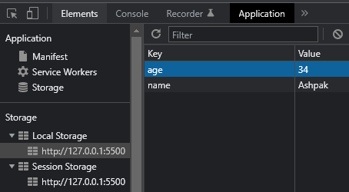

Rather than only storing single text item as value we can store arrays, JSON objects in storage.

** Local storage only store data in text format, so we need to convert data in text format using JSON.parse() before storing in storage and after reading back we need to again convert to original format using JSON.stringify()

Here is example how to store and retrieve tasks list in storage, so that even if browser is closed and reopened tasks list will be retrieved persistently.

let frmTask = document.getElementById('task-form');

// add event handler to form for submit action

frmTask.addEventListener("submit",handleSubmit);

function handleSubmit(e){

    let tasks = [];

    //tast textbox element

    let taskItem = document.getElementById('task')

    if(localStorage.getItem('Tasks') === null){

        tasks.push(taskItem.value);

        // local storage stores data only in string format so we need to

        // stringify data beforeadding

        localStorage.setItem('Tasks',JSON.stringify(tasks));

    }

    else{

        // after reading string datafrmo local torage parse it to its

        // original form, in this case array

        tasks = JSON.parse(localStorage.getItem('Tasks'));

        // add new tasks item at the end of array filled with existing tasks

        // from local storage data

        tasks.push(taskItem.value);

        // add updated data to local storage

        localStorage.setItem('Tasks',JSON.stringify(tasks));

    }

    alert("Task Updated");

    e.preventDefault();

}